**Coloring game: the ‘neighbor-selection’ version**

Parameters:

***N*:** number of players in a session

***c*:** number of colors available to choose ***c =* 4(Chromatic number)**

***Tmax:*** enforced stopping time of the game

***k:*** number of neighbors = 6

Rules:

Rounds

R0: Assign a (linked) random network where each player is linked to ***k*** neighbors

R1 … m: (1). Player chooses a color, choose a partner or do nothing.

(2). When choosing a new partner, a player deletes an old link first and then links to a new neighbor.

Note: partner choice is unilateral, meaning that one can add another to his/her network without agreement of the other.

Stopping rule:

1. When all players’ colors are different than their own neighbors’ colors
2. Or the game reaches ***Tmax*** rounds
3. Or all players make no moves (changes of colors or neighbors) in consecutive 2 rounds

User interface:

Reference: Kearns, M., Suri, S., & Montfort, N. (2006). An experimental study of the coloring problem on human subject networks. *Science*, 313(5788), 824-827.

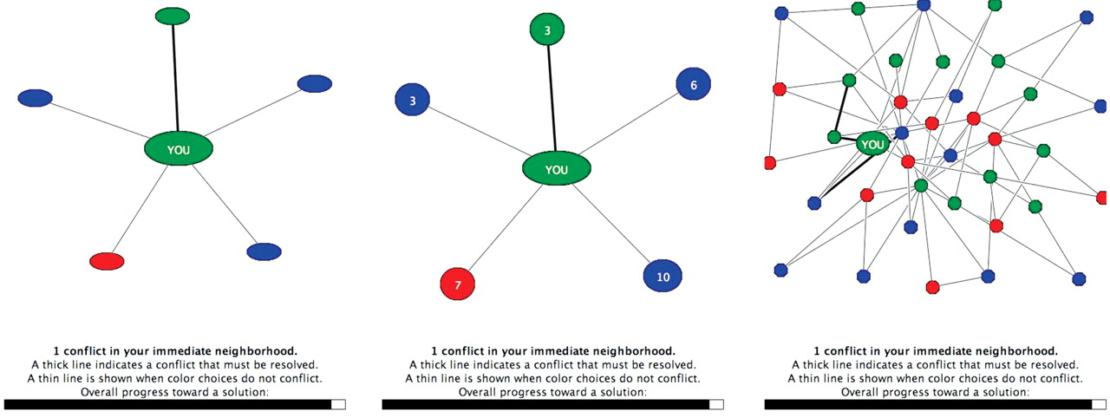

Emphasis: Neighbors whose colors are the same as the player’s color can be highlighted in bold (circles) or larger size

Scores of individual players’ performance:

*ki*: Number of neighbors of player *i*

*fi*: Number of neighbors whose colors are different from player *i*

$${Score}_{i}=\left(\frac{f_{i}}{k_{i}}\right)×100$$

Progress bars:

|  |  |  |
| --- | --- | --- |
| Index | Min/Max | Description |
| (a) | (0, *N*-1) | Number of extant neighbors |
| (b) | (0, *kt*) | Number of neighbors who choose the **same** color as player |
| (c) | (0, 100) | Player’s current score |

*kt* is the number of neighbors in the current round *t*.

Information of neighbors (revealed upon clicking)

* History: % of changing colors, % of changing neighbors, % of no-moves in the

past rounds

* Current Score
* Current number of neighbors

Test Pages

Q1: Which of the following states (around you) successfully solved the game?

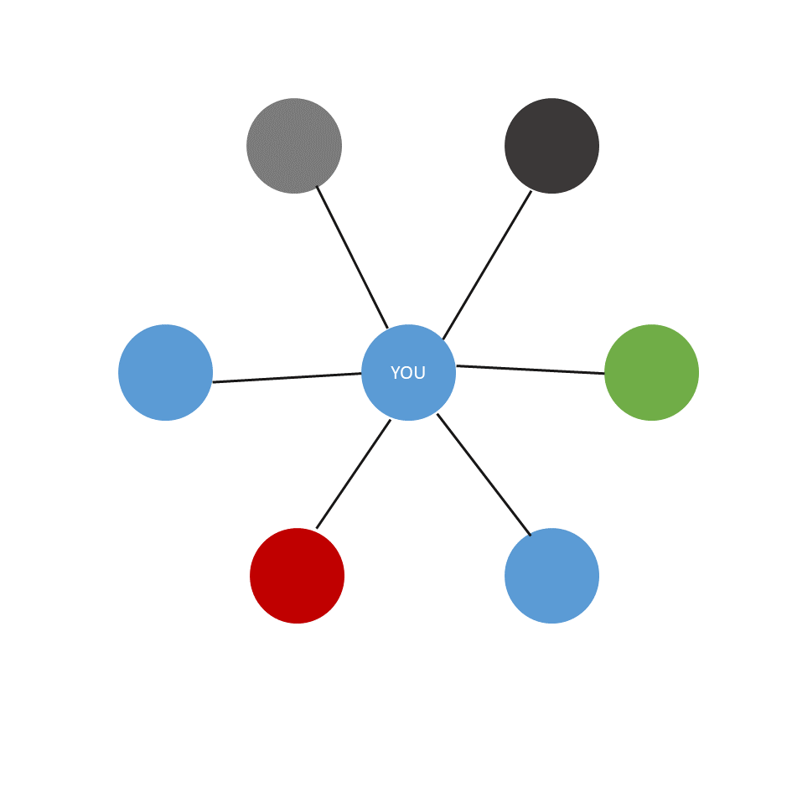 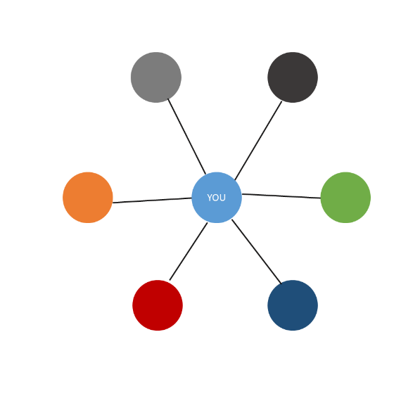

1. (b)

Q2: Which of the following states would get a higher score?

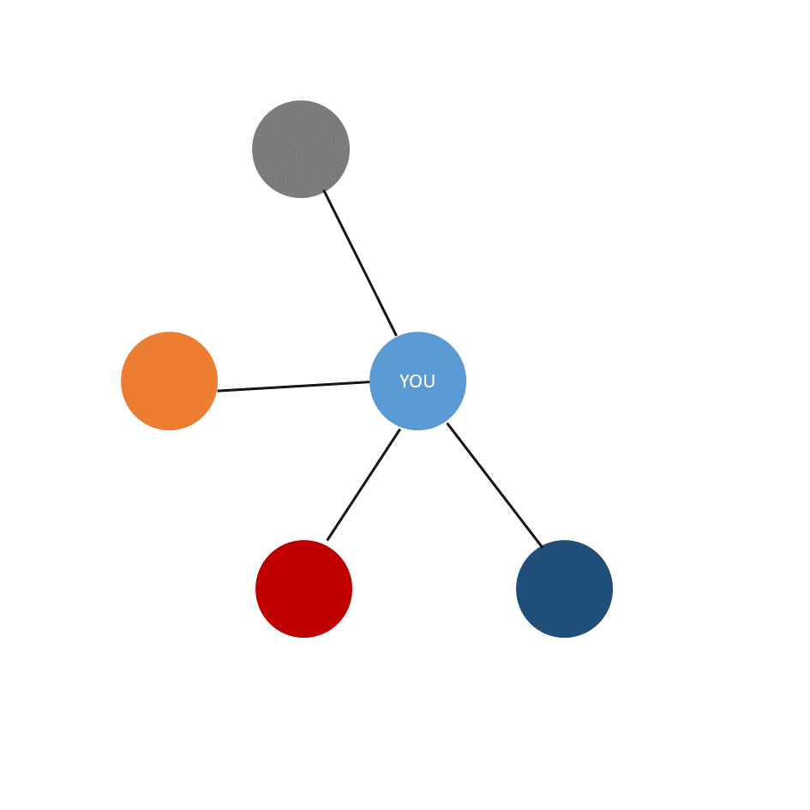

1. (b)

Q3: Which of the following states would get a higher score?

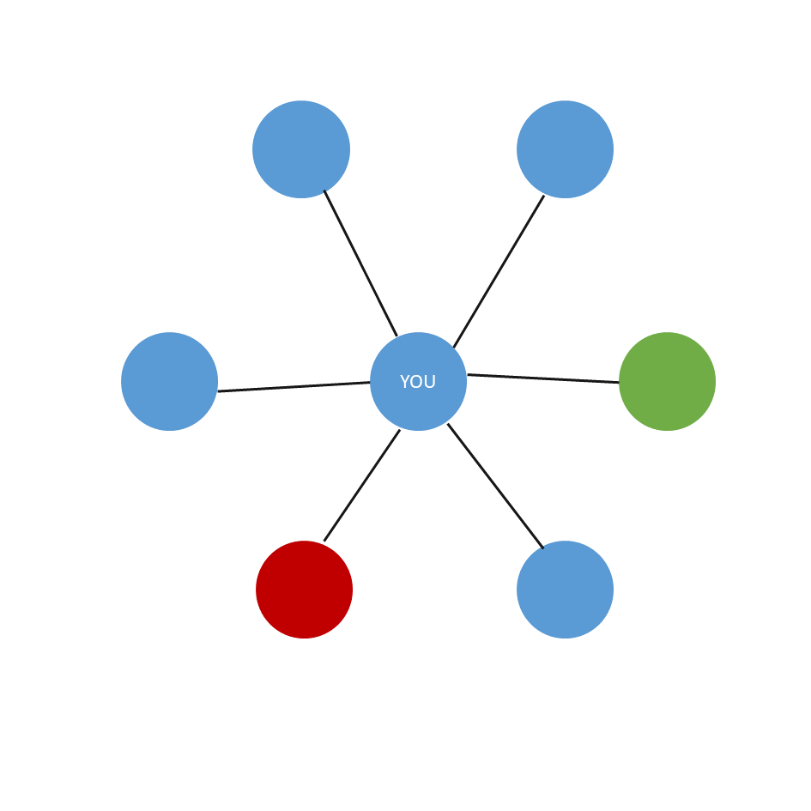 

1. (b)

Q4: In the following state, what is the percentage of success attained?

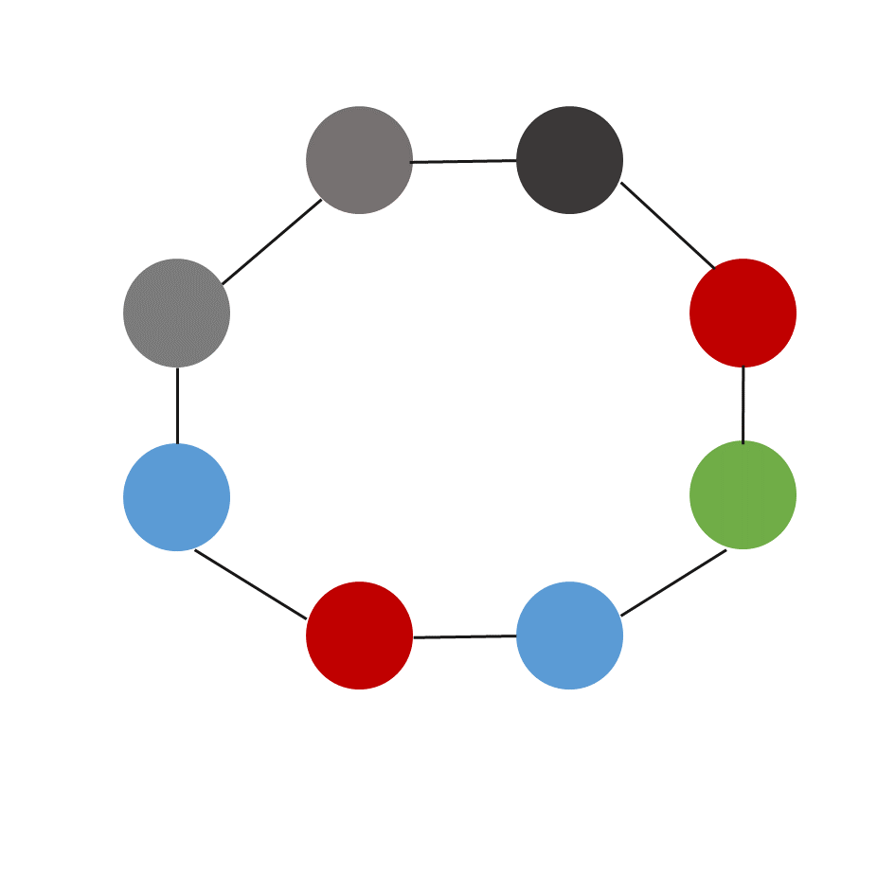

(a) 100% (8/8) (b) 75% (6/8) (c) 50% (4/8)